 | Bansilal Ramnath Agarwal Charitable Trust’s Vishwakarma Institute of Information Technology  Department of  Artificial Intelligence and Data Science
Student Name: Sathe Onkar Abasaheb
Class: TY | Division: B |  | Roll No: 372078
Semester: V |  | Academic Year: 2025-2026
Subject Name & Code: Cyber Security (AD31234B)
Assignment No: 02
Title of Assignment:
Compare and contrast substitution and transposition techniques and implement any two Methods. (Caesar cipher, Playfair cipher, Hill cipher, Vigenere cipher, Rail fence - row and column transformation)

Date of Performance: 21/07/2025 |  | Date of Submission: /08/2025

Assignment 2: Compare and contrast substitution and transposition techniques and implement any two Methods. (Caesar cipher, Playfair cipher, Hill cipher, Vigenère cipher, Rail fence - row and column transformation)

Objective:
The objective of this assignment is to compare and contrast substitution and transposition techniques and implement any two methods.

Materials Required:
Computer with Python programming environment.

Introduction to Cryptography
Cryptography, derived from the Greek words kryptos (hidden) and graphein (to write), is the science of secure communication in the presence of adversaries. The two most fundamental categories of classical cryptographic techniques are:
- Substitution Techniques – Where symbols are replaced.
- Transposition Techniques – Where symbols are repositioned.
These methods were widely used in ancient and pre-digital cryptographic systems and form the building blocks of modern encryption strategies.

Substitution Technique:

Definition:
In substitution, each element (character or group of characters) in the plaintext is systematically replaced with another symbol according to a fixed system.

Core Idea:
- The order of characters is maintained.
- Each character is transformed into another, based on an algorithm or key.
- Can be monoalphabetic (single substitution per letter) or polyalphabetic (changing substitution based on position or keyword).

Historical Use:
- Julius Caesar used a form of substitution cipher (now named after him) to send military commands.
- The Vigenere Cipher, once considered unbreakable, was used for centuries in diplomatic communications.

Advantages:
- Easy to implement and understand, especially for educational purposes.
- With complex keys (like in Vigenere), resistance to simple attacks increases.

Limitations:
- Most substitution ciphers are vulnerable to frequency analysis, especially monoalphabetic ones.
- Patterns in the plaintext often persist in the cipher text.

Transposition Technique: Concept and Theory

Definition:
In transposition, characters in the plaintext are rearranged based on a specific rule or pattern. The original characters are preserved but their positions are changed.

Core Idea:
- Does not replace characters.
- Alters the sequence or arrangement using keys or patterns.
- Decryption involves reconstructing the original order.

Historical Use:
- The Scytale cipher, used by the Spartans, is a cylindrical transposition method.
- Rail Fence and Columnar Transposition were used during World Wars I and II.

Advantages:
- Preserves letter frequencies, which makes frequency analysis less useful.
- Can be significantly stronger when combined with substitution.

Limitations:
- Still vulnerable to pattern-based and brute-force attacks.
- Key management (like number of rails or column order) becomes essential.

Implementation of Selected Methods

Caesar Cipher – A Classical Substitution Cipher

Working Principle:
- Each letter is shifted a fixed number of places along the alphabet.
- For example, with a shift of 3: A → D, B → E, Z → C, etc.
- Decryption involves shifting in the opposite direction.

Encryption Formula:
Encrypted Letter = (Original Letter + Shift) mod 26

Decryption Formula:
Decrypted Letter = (Encrypted Letter - Shift) mod 26

Security Insight:
- Only 25 possible keys for the English alphabet (excluding 0), making it easily brute-forceable.
- Any intercepted cipher text can be cracked using a frequency analysis or exhaustive key trial.

Rail Fence Cipher – A Row Transposition Cipher

Working Principle:
- Characters are written in a zigzag fashion across a set number of rails.
- The cipher text is obtained by reading row by row.
- Decryption is done by reconstructing the rail pattern using the cipher length and number of rails.

Example (3 Rails):
Plaintext: HELLOCRYPTO
Zigzag Writing:
H L C P
E L O R Y T
L O O
Cipher text (row-wise): HLCPELORYTLOO

Security Insight:
- Harder to break than Caesar due to position scrambling.
- However, if the rail count is known, decryption becomes straightforward.
- Best used as part of a compound cipher.

In-depth Comparison: Substitution vs Transposition
Criteria | Caesar Cipher (Substitution) | Rail Fence Cipher (Transposition)
Technique Type | Substitution | Transposition
Operation | Changes actual letters | Changes position/order of letters
Complexity | Very Simple | Moderate
Security Level | Very Weak (easy to break) | Moderate (if key is hidden)
Frequency Pattern | Not preserved | Preserved
Brute Force Risk | High (only 25 keys) | Lower (depends on rails and length)
Decryption Requirement | Simple shift reversal | Exact rail count and zigzag pattern reconstruction
Use in Real Systems | No (educational use only) | No (used historically, rarely in practice today)
Modern Use Relevance | Foundation of learning cryptography | Historical relevance in war-time ciphers

Real-world Relevance and Evolution
Though both Caesar and Rail Fence ciphers are insecure by modern standards, they are critical for understanding how encryption evolved. Modern encryption systems, such as AES (Advanced Encryption Standard), rely on a combination of:
- Substitution operations (S-Boxes) – derived from substitution techniques.
- Permutation (or transposition) steps – to disperse patterns.
This confusion and diffusion approach (Shannon’s principles) draws heavily from the concepts behind classical ciphers.

CODE / OUTPUT -

Caesar Cipher

def caesar_encrypt(text, shift):

result = ""

for char in text:

if char.isalpha():

offset = 65 if char.isupper() else 97

result += chr((ord(char) - offset + shift) % 26 + offset)

else:

result += char

return result

def caesar_decrypt(cipher, shift):

return caesar_encrypt(cipher, -shift)

text = input("Enter text: ")

shift = int(input("Enter shift value (e.g., 3): ")

encrypted = caesar_encrypt(text, shift)

decrypted = caesar_decrypt(encrypted, shift)

print("=" * 45)

print(f" Original Text : {text}")

print(f" Encrypted Text: {encrypted}")

print(f" Decrypted Text: {decrypted}")

print("=" * 45)

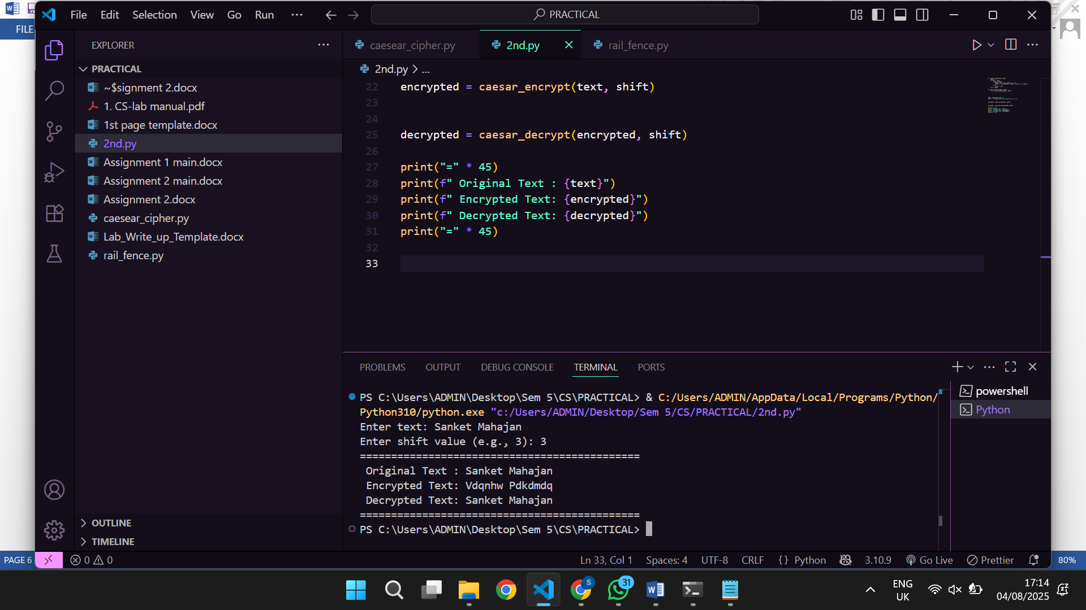

Rail Fence Cipher

def encrypt_rail_fence(text, rails):

fence = ['' for _ in range(rails)]

rail = 0

direction = 1

for char in text:

fence[rail] += char

rail += direction

if rail == 0 or rail == rails - 1:

direction *= -1

return ''.join(fence)

def decrypt_rail_fence(cipher, rails):

length = len(cipher)

pattern = [['' for _ in range(length)] for _ in range(rails)]

rail = 0

direction = 1

for i in range(length):

pattern[rail][i] = '*'

rail += direction

if rail == 0 or rail == rails - 1:

direction *= -1

index = 0

for r in range(rails):

for c in range(length):

if pattern[r][c] == '*' and index < len(cipher):

pattern[r][c] = cipher[index]

index += 1

result = ''

rail = 0

direction = 1

for i in range(length):

result += pattern[rail][i]

rail += direction

if rail == 0 or rail == rails - 1:

direction *= -1

return result

text = input(" Enter the message: ")

rails = int(input(" Enter number of rails (e.g., 3): "))

encrypted = encrypt_rail_fence(text, rails)

decrypted = decrypt_rail_fence(encrypted, rails)

print("=" * 40)

print(f" Original Message : {text}")

print(f" Encrypted Message: {encrypted}")

print(f" Decrypted Message: {decrypted}")

print("=" * 40)

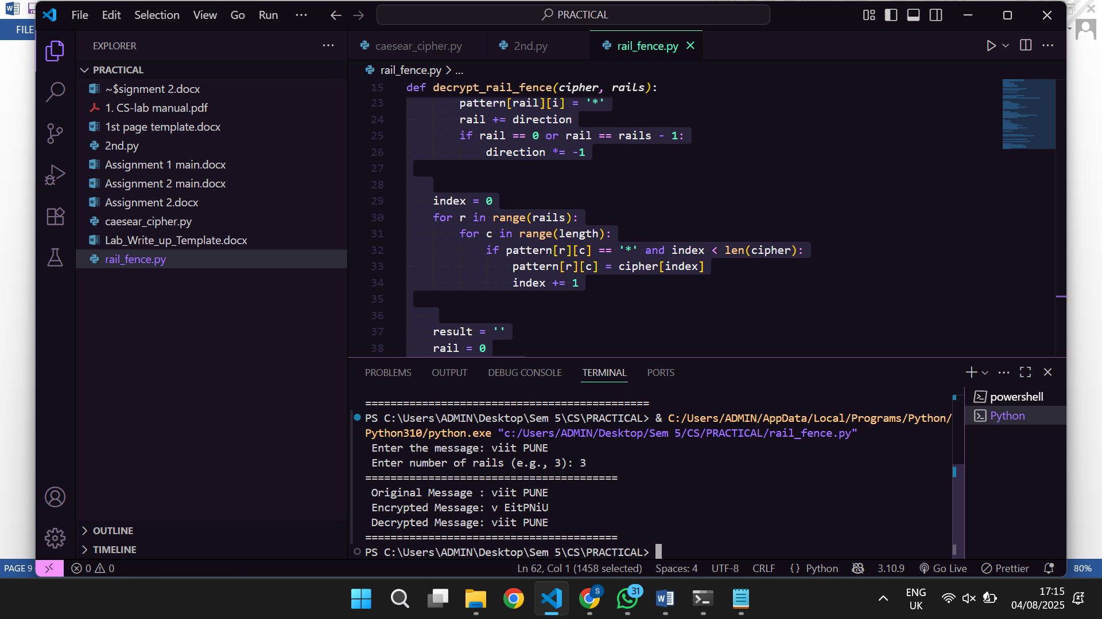

Conclusion
- Substitution and Transposition are foundational encryption methods that demonstrate how data can be obscured using simple logic.
- We implemented two classical algorithms: Caesar Cipher (substitution-based) and Rail Fence Cipher (transposition-based).
- The Caesar cipher replaces characters, while the Rail Fence rearranges them.
- Both methods have educational value and help illustrate core principles of cryptography, though they are not secure for practical usage today.
- Understanding these techniques is essential for grasping how modern cryptographic systems are structured — where such simple operations are layered, randomized, and combined with complex mathematics to achieve strong encryption.

